1. **Lazy Loading**

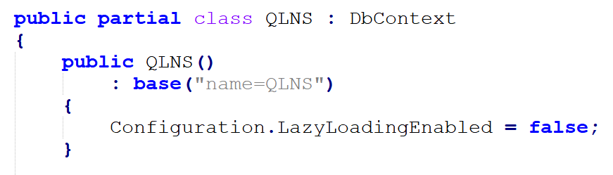

Configuration.LazyLoadingEnabled = false;

return db.NHANVIENs.Include(n => n.CHUCVU).ToList();

**=> muốn sài Include thì phải tắt Lazy Loading**

1. **Connection Strings**

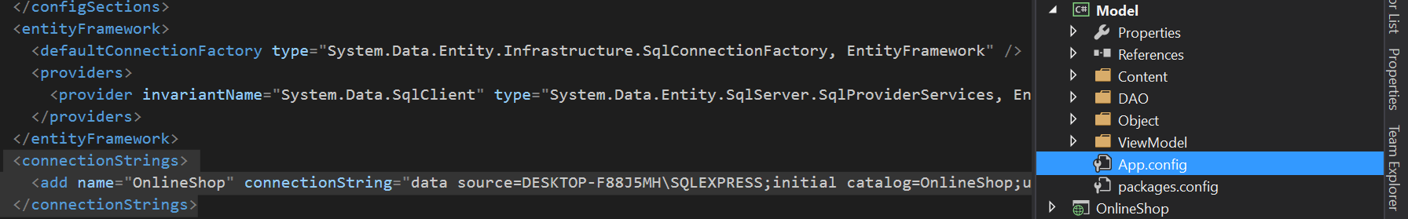

**=> Copy**

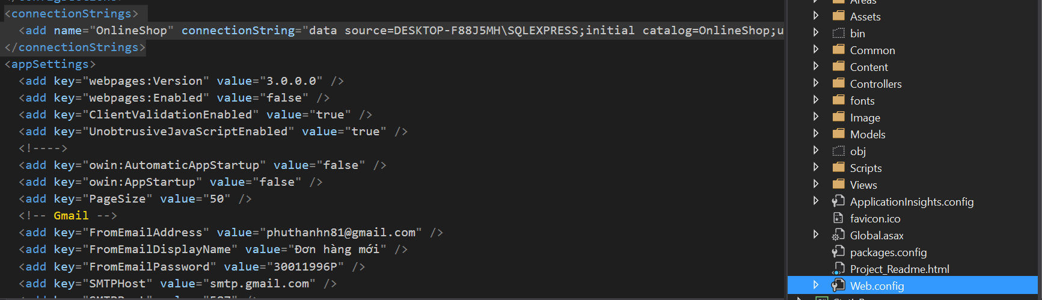

1. **Join**

